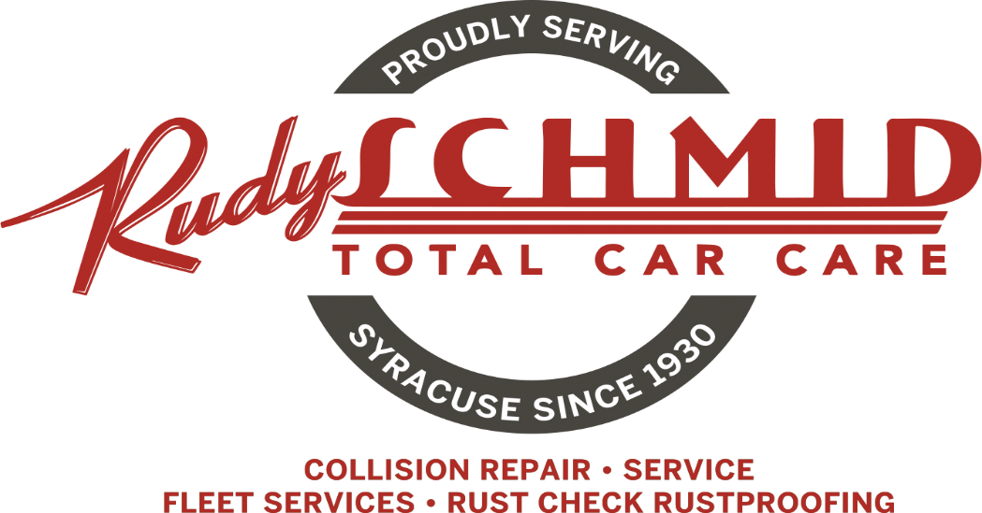
Pay with Cash or Check & Save

 |  | Cash or
Services Charges |  | Check |  | Card
Paint & Body Labor | HR | $70.00 |  | $71.93
Frame Labor | HR | $107.00 |  | $109.94
Mechanical Labor | HR | $130.00 |  | $133.58
Unibody/Framework Set-up & diagnosis | & up | $170.00 |  | $174.68
Outside Storage | Day | $75.00 |  | $77.06
Inside Storage | Day | $475.00 |  | $488.06
Diagnostic Charge |  | $135.00 |  | $138.71
NYS Inspection |  | $21.00 |  | $21.58
Additional Services
Wheel Alignments
Cars, Minivans & Small SUV's |  | $109.00 |  | $112.00
Pickups, Vans, Large SUV's |  | $119.00 |  | $122.27
Street Rods, Lowered Vehicles | & Up | $150.00 |  | $154.13
Motor Homes | & Up | $150.00 |  | $154.13
Rotate 4 Wheels & Balance | & Up | $75.00 |  | $77.06
Oil Change & Filter | & Up | $90.00 |  | $92.48
Rust Check Corrosion Protection
Passenger Cars |  | $160.00 |  | $164.40
Small SUV's, Mini Vans & 2 Door P/UPS |  | $175.00 |  | $179.81
Small SUV's, Mini Vans & 2 Door P/UPS |  | $180.00 |  | $184.95
Vans, Large SUV's & 4 DR P/UPS |  | $190.00 |  | $195.23
Also Available
Brakes, Suspension, Maintenance & Tires
Pricing available Upon Request

